 |  | Quotation
 |  | Quotation No. | :
 |  | Our Reference | :
 |  | Date | :

Your reference:

Dear Sirs

We thank you very much for your inquiry and are pleased to offer as follows:

1 | DYNO®-MILL ECM-AP 05 ceramic
Advanced Performance Series

1 – Principal Characteristics
2 – General Technical Data
3 – Machine Execution
4 – Product Pump FZ 150
5 – Motor Starter Cabinet MSC-WAB VIEW
6 – Price Summary
7 – Options and Accessories
8 – Terms of Delivery

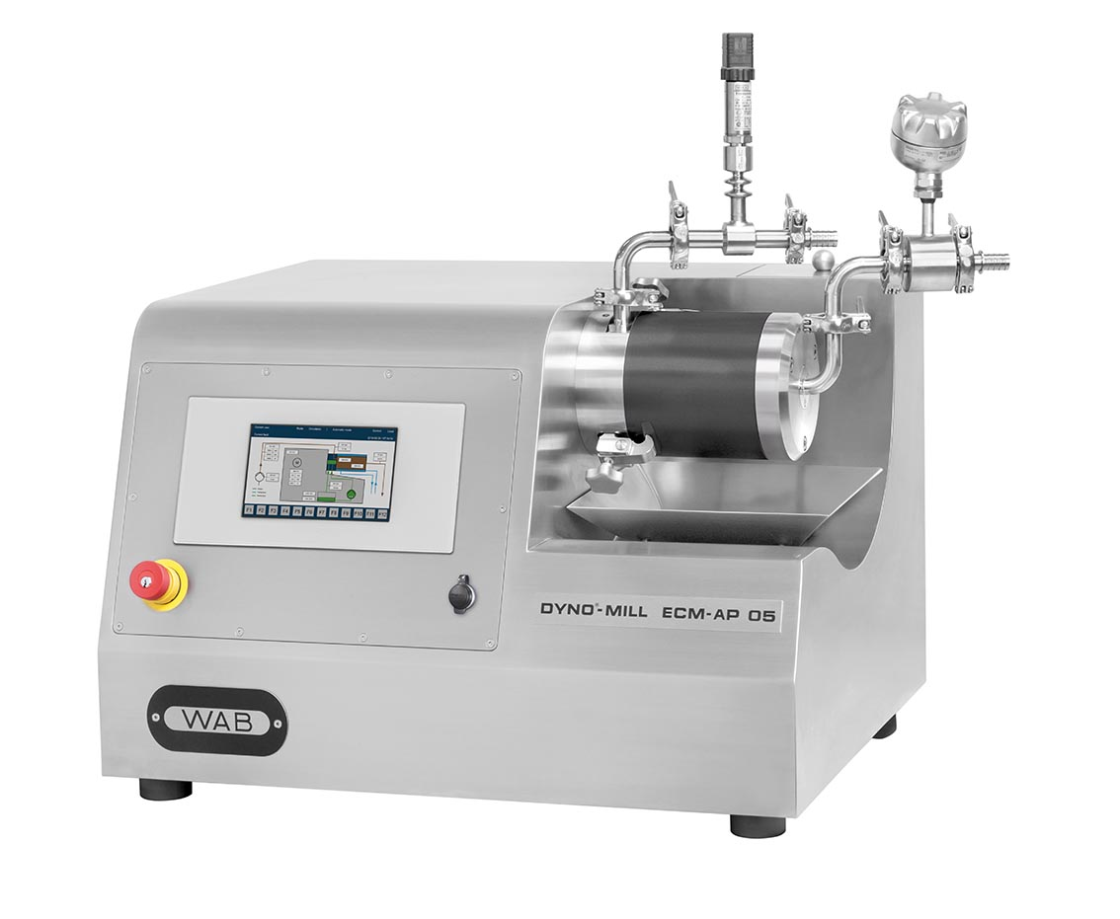

(Picture does not conform exactly to the quotation)

1 – Principal Characteristics

Working principle
- High-Efficiency Agitator Bead Mill using the “Patented” DYNO®-ACCELERATOR grinding principle
- The DYNO®-ACCELERATOR ensure powerful hydraulic movement of the grinding beads and guarantee high & uniform energy input
- DYNO®-ACCELERATOR are designed to achieve the narrowest possible Particle Size Distribution
- Grinding media separation by means of the unique combination of the
DYNO®-ACCELERATOR and the new WAB separation system ADVANCED which permits the use of grinding beads from 0.1 mm - 1.25 mm
- Most efficient heat transfer allows for superior cooling, permitting the processing of heat-sensitive products
- Lowest power consumption due to highly efficient energy input (low carbon footprint)
Unique Process Flexibility
- Suitable for dispersion and wet grinding of low to high viscosity products
- Wide range of energy input allows dispersing/grinding of a broad range of products at its optimum parameters
- Suitable for both, passage- and circulation processes
- Suitable for batch sizes from 1 litre suspension
- Laboratory mill for scale-up to the larger models of the DYNO®-Mill ECM-AP series
Design
- Designed to ensure optimal ergonomics & user-friendly handling
- Reduced noise emission by mill motor placed inside the machine housing
- Easy operation & adjustment of operation parameters
- Built-in safety features
Cleaning & Maintenance
- Self Cleaning effect of grinding chamber
- Short Cleaning Times using the smallest quantities of cleaning fluids, resulting in
- faster product turnarounds
- reduced costs for cleaning fluids & recycling
- less exposure to solvents by operator and environment
- Machine housing of stainless steel easy to clean
- Easy accessibility to all parts reduces handling time to a minimum
- Double mechanical seal from WAB for long life and low maintenance costs

2 – General Technical Data

Conformity
EC Declaration of Conformity: | covered by the Directive 2006/42/EC on machinery, Annex II A, and the ATEX directive 2014/34/EU, Annex VIII
Explosion protection of the machine: |  II 3 G Ex h IIB T3 Gb
Protection: | IP 55 (acc. IEC 60529)

Electrical specifications
Operating voltage: | 400 V, 50 Hz (3 phases)
Control voltage: | 24 VDC

Grinding unit
Grinding cylinder volume: | 0.5 litres
Max. working pressure: | 2.0 bar
Working temperature: | 5 °C - 85 °C
Product inlet: | Tri-Clamp connection Ø 25 mm acc. DIN 32676 for tube acc. DIN 11866 line B DN/OD  Ø 17.2 mm with hose connection Ø 17.2 mm and with PTFE seal
Product outlet: | Tri-Clamp connection Ø 25 mm acc. DIN 32676 for tube acc. DIN 11866 line B DN/OD  Ø 17.2 mm with hose connection Ø 17.2 mm and with PTFE seal

Cooling water circulation system
- Central cooling water connection for the cooling of the grinding unit and rinsing liquid device: | With hose connection for hose inside diameter 10 mm
- Cooling water information
Flow rate: | 250 – 400 l/h
Pressure drop (with free outlet): | 1.5 – 3.5 bar
Max. cooling water pressure: | 5.0 bar
- Cooling water temperature range: | -15 °C - +50 °C
- Recommended cooling water temperature: | Below 10 °C

Machine Housing
Housing material: | Stainless steel with polished surface quality
Dimensions L x W x H: | Approx. 825 x 625 x 725 mm
Weight: | Approx. 120 - 140 kg

3 – Machine Execution

3.1 Grinding Unit
1 | Cooling cylinder made of anodised aluminium for lightweight handling and easy access to the milling chamber / DYNO®-ACCELERATOR
1 | Grinding cylinder made of wear resistant silicon carbide
1 | Front cover of stainless steel with product outlet connection
1 | Set of DYNO®-ACCELERATOR made of zirconium oxide / silicon carbide
1 | WAB separation system ADVANCED with screen disc of zirconium oxide
1 | Cylinder Screen 0.25 mm, pure nickel, hard chromium plated
1 | Set of spacers of zirconium oxide / silicon carbide including electrically conductive-/FDA compliant taper seals
 | All product contacted O-rings of perfluorelastomer
 | All remaining parts in contact with the grinding beads of zirconium oxide / silicon carbide

3.2 Shaft Sealing
1 | Double mechanical seal from WAB  Product side and atmosphere side sliding rings made of wear resistant silicon carbide; fully sealed with perfluorelastomer O-rings
1 | Rinsing and pressurising of the shaft seal by means of a directly driven stainless steel gear pump type ZR 3030  The operating pressure is fix and not adjustable  Cooled rinsing liquid reservoir of stainless steel
1 | Separate leakage container for the rinsing liquid

3.3 Drive Unit
1 | Mill motor 4 kW, 3 x 400 V, 50 Hz, 3000 min⁻¹  II 2 G Ex db eg IIC/B T4 Gb, IP 55, with 3 PTC-probes
1 | Pulley and antistatic Poly-V-belt for DYNO®-ACCELERATOR tip speed of  6-16 m/s

3.4 Sensors and Control Unit
1 | Explosion protection of sensors according  Directive 2014/34/EU concerning equipment and protective systems intended for use in potentially explosive atmospheres  II 2 G Ex ia/ib IIC T4-T6 Gb
Safety and control instruments consisting of
- One inductive proximity switch to prevent start of the mill when grinding container is removed
- One integrated limit switch to prevent start of the mill when the drive unit access door is open
- Pressure transmitter in the mill inlet, with output signal 4-20 mA and Tri-Clamp connection
- Temperature transmitter (PT 100) in the mill outlet, with output signal
4-20 mA, pen sensor and Tri-Clamp connection
- Flow controller for monitoring of the buffer circuit
- Instruments connected in a junction box for connection
to electric circuit II 2 G Ex ia/ib IIC T4-T6 Gb, without relays

1 | Mill Control Unit WAB VIEW mounted in the machine housing (inside wired on terminals) for control voltage 24 VDC  - Touchdisplay (7" TFT)  Explosion protection II 3 G Ex ec IIC T4 Gc  Protection Front side IP 65, back side IP 20  - USB interface for transmission of process parameters on USB-Stick  - EMERGENCY STOP button mounted separately in the machine housing  Explosion protection II 2 G Ex db eb IIC T6 Gb  Protection IP 65

3.5 Machine Housing & Support material
1 | Machine housing made of stainless steel
1 | Stainless steel collecting dish for the grinding beads
1 | Toolbox for dismantling of the mill parts
1 | Set of torque wrenches
1 | Funnel made of stainless steel for filling of grinding beads
1 | Operational Manual in English

Price Machine Execution zirconium oxide | CHF | 58'955.00

Price Machine Execution silicon carbide | CHF | 56'115.00

4 – Product Pump FZ 150

1 | Gear pump for throughputs up to 150 l/h
Explosion protection of the product pump:
Directive 2014/34/EU concerning equipment and protective systems intended for use in potentially explosive atmospheres
II 2 G Ex h IIB T3 Gb X
The gear pump is mounted on a separate baseplate with legs, for the operation beside the DYNO®-MILL ECM-AP 05.
Pump specification
- Motor 0.25 kW, 3 x 400 V, 50 Hz, 1500 min⁻¹
II 2 G Ex db eb IIC T4 Gb, IP 55, with 3 PTC probes, 5 – 80 Hz
- Reducing gear
- Single mechanical seal with O-rings (Kalrez)
- Temperature control by means of 1 PTC probe
- Nipple connection for product hose
- Filling hopper with ball valve mounted on the pump inlet
Price Product Pump |  | CHF | 6’920.00

5 – Motor Starter Cabinet MSC-WAB VIEW

1 | Important remark:  The motor starter cabinet has to be mounted outside of the explosion hazardous area.  The motor starter cabinet is delivered without cable connection to the DYNO®-MILL and the product pump.  Protection:  IP 55 (acc. IEC 60529)  - PLC controller Siemens S7 with the necessary in- and output cards and software  - Inside completely wired for connection to 3 x 400 V, 50 Hz  - Prefuses  - Transformer 400/230V for power supply of the mill control with 230 VAC / 24 VDC  - Main switch  - Contactor for the mill motor  - Contactor for the pump motor  - Frequency converter for the mill motor  - Frequency converter for the product pump motor  - Relays for safety and control instruments  - Ethernet port  - Housing of painted sheet steel (grey)
Price Motor Starter Cabinet |  | CHF | 29’970.00

6 – Price Summary

Zirconium oxide execution

3 – Machine Execution | CHF | 58'955.00
4 – Product Pump | CHF | 6'920.00
5 – Motor Starter Cabinet | CHF | 29'970.00
Price for 1 DYNO®-MILL ECM-AP 05 | CHF | 95'845.00
Packing, incl. wooden case: | CHF | 830.00
TOTAL PRICE, FCA Muttenz, packed | CHF | 96'675.00

Silicon carbide execution

3 – Machine Execution | CHF | 56'115.00
4 – Product Pump | CHF | 6'920.00
5 – Motor Starter Cabinet | CHF | 29'970.00
Price for 1 DYNO®-MILL ECM-AP 05 | CHF | 93'005.00
Packing, incl. wooden case: | CHF | 830.00
TOTAL PRICE, FCA Muttenz, packed | CHF | 93'835.00

7 – Options and Accessories
(not included in the total price)

1 | Cylinder screen 0.03 mm, pure nickel, hard chromium plated  (art. 246451) | CHF | 640.00
1 | Cylinder screen 0.07 mm, pure nickel, hard chromium plated  (art. 238955) | CHF | 640.00
1 | Cylinder screen 0.13 mm, pure nickel, hard chromium plated  (art. 238956) | CHF | 640.00
1 | Cylinder screen 0.25 mm, pure nickel, hard chromium plated  (art. 238957) (price included in chapter 3 – Machine Execution) | CHF | 640.00
1 | Cylinder screen 0.40 mm, pure nickel, hard chromium plated  (art. 238958) | CHF | 640.00

Product Pump FZ 300

1 | Gear pump for throughputs up to 300 l/h
Explosion protection of the product pump:
Directive 2014/34/EU concerning equipment and protective systems intended for use in potentially explosive atmospheres
II 2 G Ex h IIB T3 Gb X
The gear pump is mounted on a separate baseplate with legs, for the operation beside the DYNO®-MILL ECM-AP 05.
Pump specification
- Motor 0.37 kW, 3 x 400 V, 50 Hz, 1500 min⁻¹
II 2 G Ex db eb IIC T4 Gb, IP 55, with 3 PTC probes, 5 – 80 Hz
- Reducing gear
- Single mechanical seal with O-rings (Kalrez)
- Temperature control by means of 1 PTC probe
- Product connections with hose stem
- Filling hopper with ball valve mounted on the pump inlet
Price Product Pump |  | CHF | 6’990.00

Mill Control Unit WAB VIEW Pro

1 | Mill Control Unit WAB VIEW Pro, mounted in the machine housing (inside wired on terminals) for control voltage 24 VDC  - Touchdisplay (12" TFT)  Explosion protection ATEX Zone 1 and Zone 21  Protection IP 66  Processor Intel® ATOM™ E3940  RAM 8 GB  Hard disc 128 GB  Explosion protection of the machine II 2 G Ex h IIB T3 Gb  Software  Windows 10 IoT Enterprise 2021 LTSC  WinCC Runtime Advanced, Version: V17  - USB interface for transmission of process parameters USB-Stick  - EMERGENCY STOP button mounted separately in the machine housing  Explosion protection II 2 G Ex db eb IIC T6 Gb  Protection IP 65
Extra charge instead of mill control unit WAB VIEW with touch display (7” TFT) |  | CHF | 12'450.00

1 | Option for WAB VIEW Pro  Audit Trail on HMI  FDA 21 CFR Part 11 User Management  Extra charge | CHF | 4'270.00

8 – Terms of Delivery

Quotation: | FCA Muttenz (INCOTERMS 2020), packed, excluding duty and taxes to import the goods into the country of destination
Payment conditions: | 40 % at placement of purchase order  40 % before delivery  20 % at latest 30 days date of invoice / date of shipping documents  Against irrevocable and confirmed Letter of Credit to our favour through our bank. Validity of L/C should be for the period of 6 weeks beyond the date of shipment. All bank charges, incl. confirmation commission in your country as well as in Switzerland to your account.  Our bank address:  UBS Switzerland AG, 4002 Basel, Switzerland  Account Nº: 233-514570.01N  BIC (Swift Code): UBSWCHZH80A  IBAN: CH92 0023 3233 5145 7001 N
Delivery time: | Approx. weeks FCA Muttenz from receipt of down payment / L/C and after clarification of all technical and commercial details.
Customer side services: | The customer is responsible for installing and connecting the machine according to our instructions. The grinding media DYNO®-Beads to operate the agitator bead mill can be ordered with the machine or from our local representatives.
Start-up: | Will be invoiced separately from us or our representatives.
Validity: | This quotation is valid until end of XXXX.
Property reservation: | The goods remain our property without any restrictions, until fully paid.
Delivery terms: | According the document “General Conditions of Contract for the supply of machinery and spare part” in its current version provided by the following link on our web page  https://www.wab-group.com/fileadmin/GC-WAB-AG.pdf
Origin: | The above mentioned goods are of Swiss origin (HS Code 8479.82).

WILLY A. BACHOFEN AG

